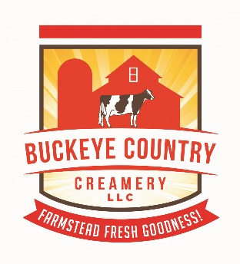
Why Try Our Handmade Milk Soap?
- Our milk isn’t just wholesome to drink…it’s great for your skin too! People have been using milk in skin care applications for hundreds of years.

- When used in soap making, the wonderful butterfat that our cows produce in their milk creates a creamy, soothing lather that not only cleans, but can help your skin stay moisturized.

- Milk contains lactic acid, so in soap this can help to gently exfoliate dead skin cells.

- Our milk soap also contains glycerin, a compound naturally produced in the soap making process. Glycerin is known to be beneficial to skin, having anti-aging and hydrating properties. However, many mass produced soap products that you might find in the grocery store have had the glycerin removed.

- To keep your skin happy and healthy, we strive to keep our recipe as simple and natural as possible. No unnecessary alcohol, dyes, petroleum products, or sulfates added.

Pick up a bar today and try it for yourself!

Info Sources:
Handcrafted Soap & Cosmetic Guild, Inc.
www.livestrong.com/article/180736-milk-soap-benefits/
http://www.skincareresourcecenter.com/natural-skin-care-recipes.html
http://thenakedchemist.com/what-is-glycerine

